From Renae’s Kitchen! Jamaican Curry Chicken Recipe
Ingredients
• 2 lbs chicken, cut into small pieces (bone-in or boneless)
• 2 tbsp Jamaican curry powder
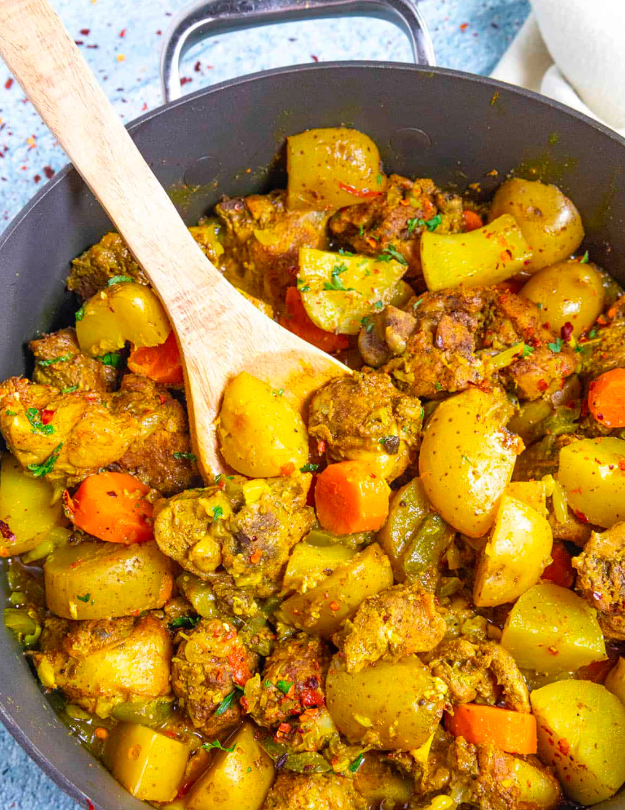
• 1 tsp turmeric (optional, for a richer color)
• 3 cloves garlic, minced
• 1 medium onion, chopped
• 1 scallion, chopped
• 1 medium potato, diced
• 1 large carrot, sliced
• 2 sprigs thyme
• 1 scotch bonnet pepper, whole or sliced (for heat)
• 1 tsp grated ginger
• 1/2 tsp all-purpose seasoning
• 1/2 tsp black pepper
• 1/2 tsp salt
• 2 tbsp vegetable oil
• 2 cups water or chicken stock

Instructions
- Season the Chicken:
  - Wash the chicken with lime or vinegar and rinse well.
  - Season the chicken with curry powder, turmeric, garlic, ginger, onion, scallion, salt, black pepper, and all-purpose seasoning. Cover and let it marinate for at least 1 hour (overnight is even better for flavor).
- Cook the Curry:
  - Heat the oil in a large pot or Dutch oven over medium heat.
  - Add 1 tbsp curry powder to the hot oil and “burn the curry” (toast it for 1-2 minutes). This helps release the flavor.
- Brown the Chicken:
  - Add the seasoned chicken pieces to the pot and stir well, coating them with the burnt curry.
  - Allow the chicken to brown lightly on both sides (5-7 minutes).
- Simmer the Chicken:
  - Add the thyme and scotch bonnet pepper to the pot.
  - Pour in the water or chicken stock to cover the chicken. Stir and bring it to a boil.
  - Reduce the heat to low-medium, cover the pot, and let it simmer for 20 minutes.
- Add Vegetables:
  - Add the diced potato and sliced carrot to the pot. Stir them in and let the dish simmer for another 15-20 minutes until the vegetables are tender and the curry thickens.
- Taste and Adjust:
  - Taste the curry and adjust the salt or pepper if needed. Remove the scotch bonnet pepper if you don’t want it too spicy.
- Serve:
  - Serve hot with steamed white rice, rice and peas, or boiled dumplings and green banana.

Pro Tips:
• For extra sauce, add a little coconut milk when simmering the vegetables.
• If you prefer mild spice, keep the scotch bonnet pepper whole; if you like it spicy, slice it!

